 |  | 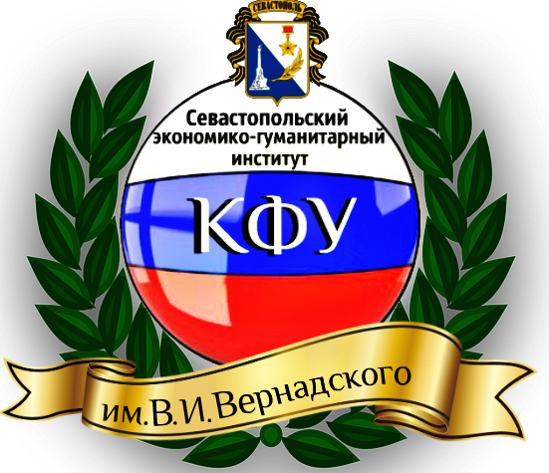
Crimean Federal University of V.I. Vernadsky | North-Caucasus Federal University | Sevastopol Economic-Humanitarian Institute (branch) of V.I. Vernadsky Crimean Federal University

Sevastopol Economic-Humanitarian Institute (branch) of V.I. Vernadsky Crimean Federal University and
North-Caucasus Federal University organize the International Conference “Management in the conditions of the global world transformations: economics, politics, law” in the city of Sevastopol on the 26-30 of April, 2017, in order to consolidate the efforts of the scientific community and practical views on topical issues in the management of the organization, legal aspects in modern economic conditions.
We are glad to invite you and your colleagues to take part in the conference.
Main issues at the conference:
-Actual trends in the management of the regional economy.
-Modern organizational management issues.
-Issues of strategic management and public policy
- Investment and Innovation management
- Technologies of management of business entities in the region
- Personnel management in the market conditions
- Actual issues of state and municipal management
- Management of finance in organizations
- Socio-psychological aspects of management
- Communicative management component
- International legal framework and national legislation in the sphere of management
Working-languages: Russian, English
The deadline for applications and articles – up to 1 of April, 2017.
The requirements for registration of articles and application for participation are presented in application A.
Form of participation in the conference: full-time or part-time participation with the presentation of the article and publication in the journal of scientific works (without arriving at the conference). The articles will be posted on the website of Sevastopol Economic-Humanitarian Institute (branch) of V.I. Vernadsky Crimean Federal University: http://segi.cfuv.ru/ during the conference. Thematic forums will be held for all sections, where scientists will be able to discuss the results of their work. The articles of the journal will be published in RSCI - SCIENCE INDEX (Russian Science Citation Index. ISBN will be given to the journal.
The membership of the organizing committee:
Lazitskaya Natalya Fedorovna, director of Sevastopol Economic-Humanitarian Institute (branch) of V.I. Vernadsky Crimean Federal University, candidate of geographic science.
Ekimova Zulfiya Zaletdinovna, deputy director for teaching and educational scientific work of Economic-Humanitarian Institute (branch) of V.I. Vernadsky Crimean Federal University.
Parakhina Valentina Nikolaevna, doctor of Economics, Professor, Head of the Management Department of NCFU, Honored Worker of Higher School, Academician (active member) of the Russian Academy of Social Science, winner of the RF Government Prize in the field of education.
Kalyugina Svetlana Nikolaevna, doctor of Economics, Professor of the Management Department of NCFU, winner of the RF Government Prize in the field of education.
Ryabtseva Elena Evgenievna, Doctor of Political Science, professor, Head of the Department of Law.
Tsybulskaia Liudmila Alekseevna, candidate of economic science, associate professor, Head of the Management Department.
Boris Olga Alexandrovna, doctor of economic science, Professor of the Management Department of NCFU.
Alekseeva Oksana Anatolievna, candidate of economic science, associate professor of the Department of Management of NCFU.

Transportation and accommodation expenses are paid by participants. Distance participation in the conference is free of charge. The accommodation of participants is offered in the hotel “Optima”:http://optimahotel.ru/ru/nomera
Responsible for the conference:
Ryabtseva Elena Evgenievna, Doctor of Political Sciences, professor, Head of the Department of Law. Telephone number: +7978 130 79 48
Tsybulskaya Liudmila Alekseevna, candidate of economic science, associate professor, Head of the Management Department. Telephone number: +7978 70 97 294

Application A
The articles, which are not previously published, are accepted for publication.
During preparing the articles for publication the editorial board of the journal asks the authors to follow next requirements:
index UDC (left top corner of the page);
information about the author (in the right top corner of the page) – authors’ surname, name and patronymic (in the nominative case, bold type); academic degree, rank, position, place of working (full-length);
the title of the article (in the center, capital letters, bold type);
summaries are printed in Russian and English languages in such order: surname, name and patronymic of the author (bold type); the title of the article (bold type); the text of the summary;
setting of the problem and its connection with important scientific or practical tasks;
analysis of recent researches and publications, which the author relied upon;
allocation of the unsolved problem, which the article is devoted to;
aim of the article;
presentation of the main research material with full justification of scientific results;
conclusions and proposals in these directions;
list of literature which is formulated according to the standards;
key words (5-11 words).
Author’s text should exceed 70%.
- the volume of the article, including the list of literature, tables, diagrams, summaries and etc. should be no more than 8 pages (page format– А4); the pages are not numerated;
- the text should be typed in Times New Roman, 12 – point type, line space - 1,5; margins: top – 2 сm, bottom – 2 сm, left – 2,5 сm, right – 1,5 сm;
- the references and commentaries should follow next requirements: the references are to be given in the square brackets, where the first figure is the ordinal number of the source from the literature list, and the second one is the correspondent page in this source, e.g. [7, С. 11]);
- illustrative material should follow next requirements: graphics and diagrams should be made in Microsoft Excel; formula should be given in Math Type 5.0 or Microsoft Equation;
- the article (file’s name includes the surname of the author in English) should be typed in Microsoft Word 97-2013;
the text of the article is sent by e-mail: kaf_segi@mail.ru
- editorial board may shorten and edit the manuscript;
- the author is responsible for the content.

APPLICATION  to International conference  «Management in the conditions of global world transformations: economics, politics, law»  (11 – 15 of May 2016, c. Sevastopol)  Name of the author __*___________________________________  Academic degree/rank *__________________________  Higher Educational Establishment/ Organization*_____________  Theme of the report *_________________________________  Home address * _______________________________________  Contact phone number_____________________________________  E-mail ________________________________  Plan to speak (yes, no) ___________________________  To perform with the report (10 min)  To perform with the information (5 min)  To participate as a listener  Using multimedia technology ______________  * fill in Russian language | UDC 332.1  Stepanova А.S., Ph.D, associate professor  North-Caucasian Federal University,  c. Stavropol  FEATURES OF THE REGIONAL MANAGEMENT OF THE ECONOMY  Stepanova A.S. Features of the regional management of the economy. The article shows…  Степанова А.С. Особенности управления региональной экономикой. Сделан анализ…  Setting of the problem ….  Analysis of the last investigations and publications.  The purpose of the article - …  Presentation of the basic material of the article.  Conclusions:  List of literature:  Key words: management, economy…

Thank you for accurate and full information, which is presented beforehand.

